Student Name: Taahir Basson
Student Number: ST10282092
Module: PROG7312 Formative 1 — Part 1
Topic: Smart-X Data Ingestion and Validation Gateway

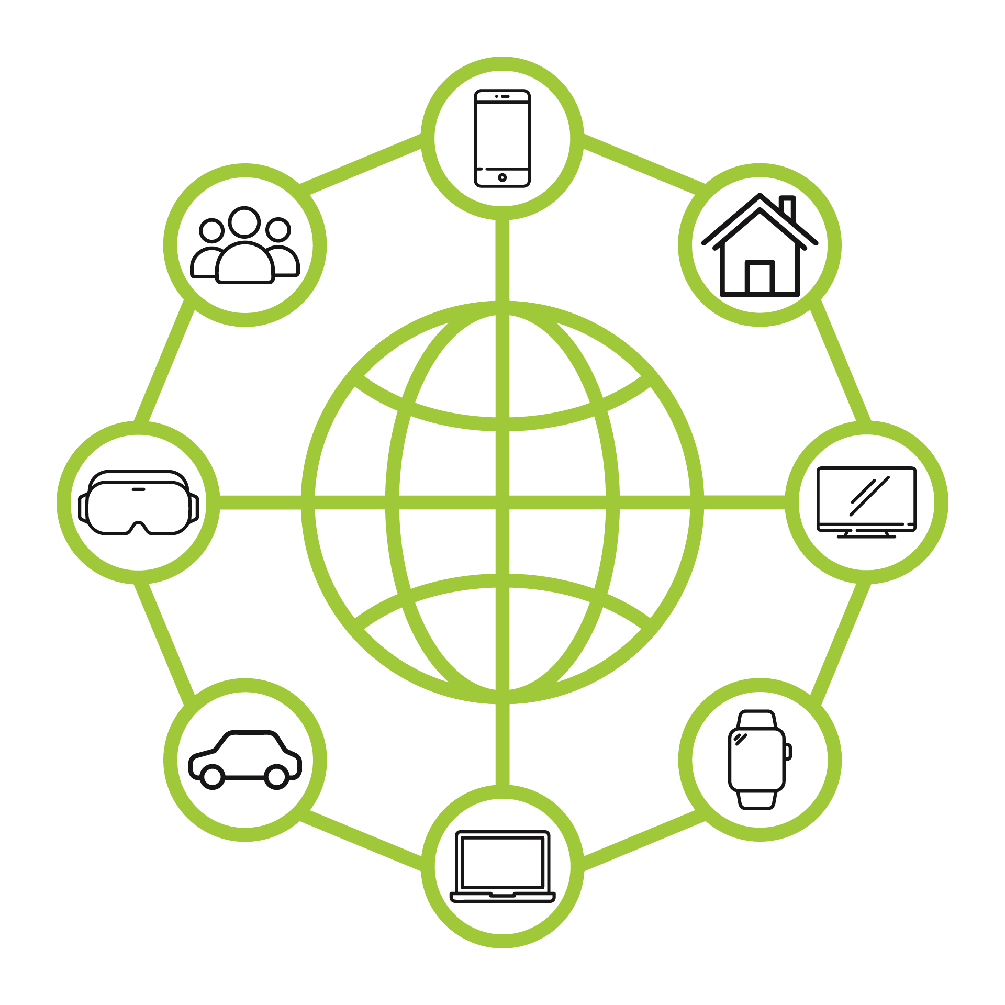

1. Developer-Centric User Engagement Strategies
To effectively manage high-throughput IoT telemetry and prevent operator drop-off, the following five developer-centric dashboard interactivity strategies were evaluated for the Smart-X technical management interface:
- Interactive Topology Heatmaps: A spatial visualization strategy where physical or logical mesh networks are graphically mapped, with individual sensor nodes dynamically changing color (e.g., green to crimson) based on real-time telemetry thresholds.
- Contextual Anomaly Highlighting (Smart Baselines): An algorithmic UI feature that suppresses standard operating data and actively highlights only the data points that deviate from calculated historical moving averages, drawing developer attention directly to statistical outliers.
- Time-Series Data Scrubbing & Zooming: An interactive timeline control that allows operators to drag across a visual chart to instantly filter and query the underlying raw diagnostic log tables for a specific microsecond window.
- Proactive Alert Gamification: A developer-focused triage system that rewards system operators (e.g., tracking resolution streaks or time-to-acknowledge metrics) for rapidly mitigating sensor disconnects or acknowledging critical threshold breaches.
- Visual Drag-and-Drop Node Onboarding: A simplified configuration flow replacing complex CLI registration, allowing developers to drag an unregistered device MAC address onto a digital zone blueprint to instantly provision and configure the node's routing context.

2. Explanation and Justification: Interactive Topology Heatmaps
Overview and the Problem of Alert Fatigue
The sheer volume and velocity of continuous telemetry data often overwhelms system operators and developers in high-throughput Internet of Things (IoT) ecosystems such as the planned Smart-X platform. Traditional tabular data grids are insufficient to give situational awareness when thousands of edge devices, such distant ESP32 microcontrollers, simultaneously publish a variety of data types, such as floats for soil moisture, integers for power measurements, and booleans for valve states.Because debugging consoles grow too complex and cognitively taxing for quick diagnoses, this condition, commonly known in systems engineering as "alert fatigue," results in significant user drop-off (Endsley, 2016). Operators grow numb to frequent numerical updates, which causes them to overlook important system malfunctions. The best and most developer-focused engagement method for the Smart-X client-facing configuration dashboard is to use an Interactive Topology Heatmap to counteract this cognitive overload.
Spotting Anomalous Data Spikes
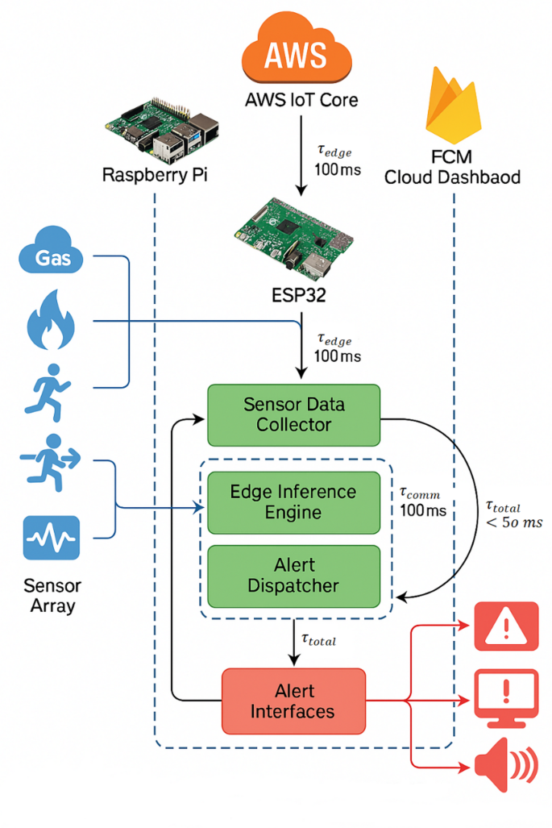
Identifying Unusual Data Spikes
The potential of a topological heatmap to drastically change the operator's cognitive load from reading raw numerical tables to comprehending intuitive visual and spatial links is the main argument in favour of using it (Hasan et al., 2019). A typical database view needs the user to cognitively analyse standard deviations and historical averages across hundreds of rows at once while monitoring moisture levels in a hydroponic farm or watching power consumption in an automated real estate utility tracker. An interactive heatmap, on the other hand, directly projects this information onto an architectural node graph or digital twin of the actual deployment zone. real estate utility tracker or monitoring moisture levels in a hydroponic farm, a standard database view requires the user to mentally parse standard deviations and historical averages across hundreds of rows simultaneously. In stark contrast, an interactive heatmap maps this telemetry directly onto a digital twin or architectural node graph of the physical deployment zone.

The particular node on the heatmap rapidly blossoms into a high-contrast warning colour, like a flashing red or a severe crimson, if there is an abnormal power rise. Human pre-attentive processing—the brain's capacity to interpret visual characteristics like colour and spatial location in less than 200 milliseconds—is leveraged by this visual signal. This eliminates the need for complicated SQL queries or manual data parsing, enabling developers to quickly identify intensity increases. The Time-to-Detect (TTD) for important threshold breaches is significantly reduced by presenting data intensity as a dynamic colour gradient, allowing proactive rather than reactive system management.

Troubleshooting Sensor Disconnects and Mesh Failures
Beyond identifying active data anomalies, the heatmap strategy excels in diagnosing "dead" or dropped nodes, which is notoriously difficult in high-throughput streams. In a distributed Smart-X mesh network, if an ESP32 chip loses its Wi-Fi connection, suffers a hardware failure, or experiences power loss, a tabular dashboard simply stops updating that specific row. This represents a silent failure that easily slips past operators in text-heavy environments.
The interactive heatmap resolves this critical vulnerability by dynamically rendering unresponsive nodes as grayed-out, hollow, or flashing disconnected icons. Furthermore, because the nodes are mapped strictly according to their physical location or logical mesh network topology, operators can instantly contextualize the nature of the disconnect (Maksimović et al., 2020). If a single node turns gray while surrounding nodes remain active, it clearly indicates an isolated hardware failure or localized battery death. However, if an entire cluster or sub-zone turns gray simultaneously on the visual map, the developer immediately recognizes a broader infrastructural issue, such as a localized gateway failure, a severed mesh routing path, or a regional power outage.
Conclusion
By visualizing data spatially, the Interactive Topology Heatmap transforms the Smart-X gateway from a passive, text-heavy monitoring console into an active, diagnostic workspace. It engages developers by providing immediate, clear, and actionable feedback, fundamentally reducing the friction of system maintenance. This visual engagement ensures that anomalous data spikes and critical sensor dropouts are caught and troubleshot with maximum efficiency, directly preventing the user drop-off associated with complex IoT administration.

Github/Youtube
https://youtu.be/L0ONczeCq78

https://github.com/BlueTai/ST10282092_Prog7312_Poe.git

References

- Endsley, M.R., 2016. Designing for situation awareness: An approach to user-centered design. 2nd ed. Boca Raton: CRC Press.
- Hasan, M., Islam, M.M. and Zarif, M.I.I., 2019. Visualizing IoT data for smart city applications. IEEE Internet of Things Journal, 6(5), pp. 8234-8245.
- Maksimović, M., Vujović, V. and Perišić, B., 2020. A custom Internet of Things GUI for efficient mesh network monitoring and fault detection. Journal of Network and Computer Applications, 154, p. 102538.

